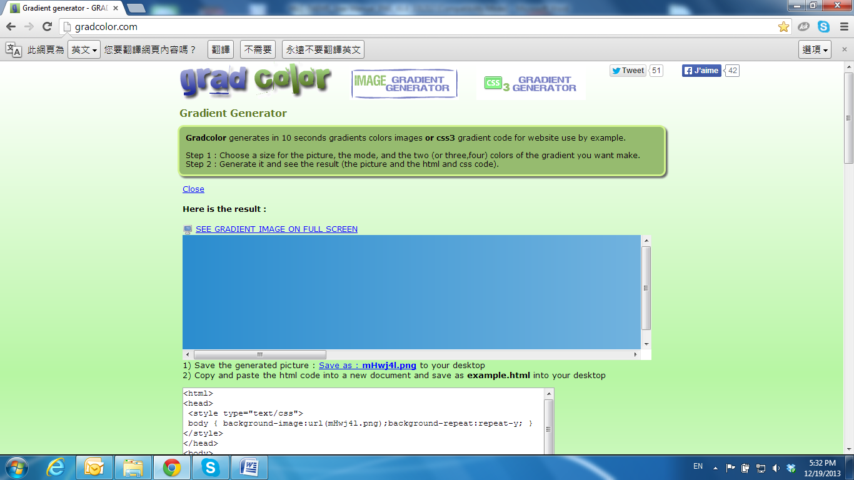

Event List

Click 83-003 to get into the administration page. Click 83-007 to go back to the live video page.

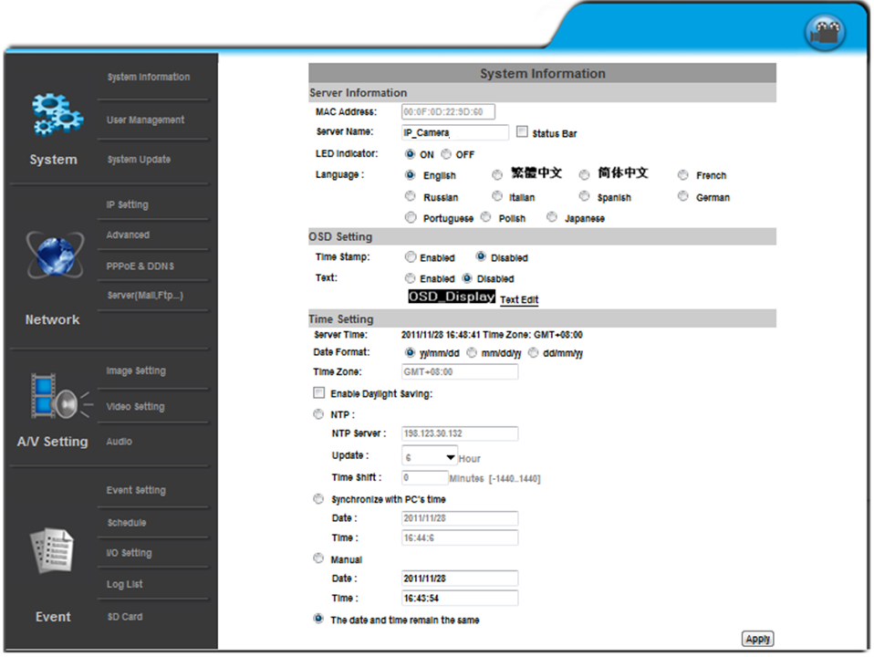

The IP Camera provides multiple event settings.

**1. Event Setting**

a. Motion Detection

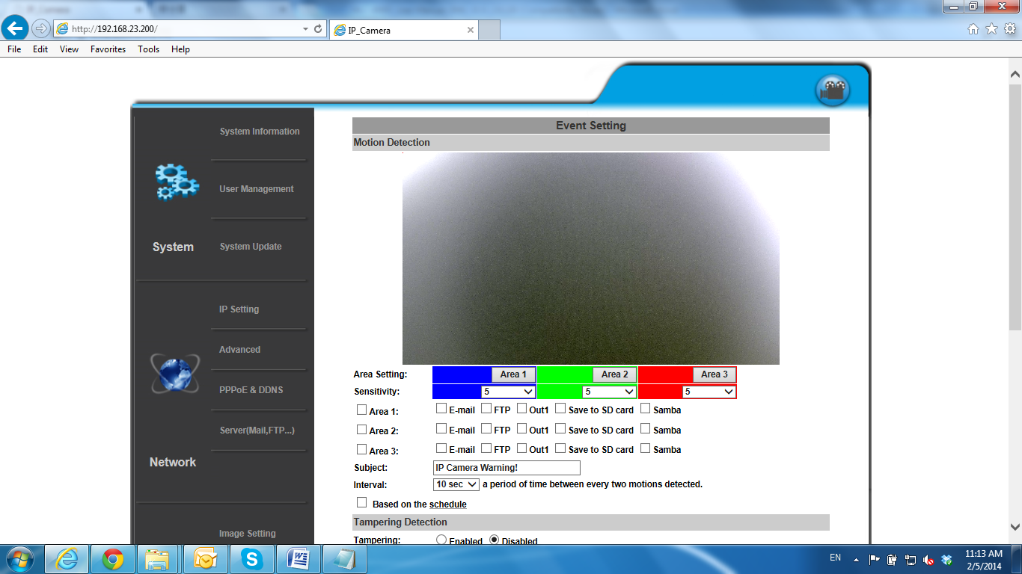

To enable motion detection, tick **Area 1/2/3**. Click **Area 1/2/3** in **Area Setting**, and draw an area on the preview screen. When motion is detected in the area, the word **Motion!** will be displayed on the live screen. The camera will send video or snapshot to specific mail addresses, trigger the output device, or save video to FTP/ Micro SD card/ Samba.

By selecting **save to SD card**, the video or snapshot will be saved to the Micro SD card. Also, by ticking **E-mail/ FTP/ Samba** on the **Log** option, the motion detection log will be sent to **E-mail/ FTP/ Samba** simultaneously.

• Interval: For example, when selecting **10 sec**, once the motion is detected and the action is triggered, it cannot be triggered again within 10 seconds.

• Based on the schedule: When the option box is ticked, only during the selected schedule time the motion detection is enabled.

b. Tampering Detection

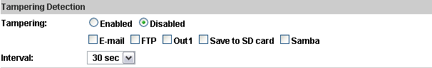

When the camera view is covered, moved, hit by strong light, or out of focus, the tampering detection will be triggered, and send snapshot or video to mail/FTP/Samba/SD card, or trigger the external alarm. For example:

Before Tampering Detection Tampering Triggered (Defocused)

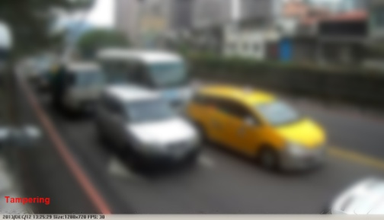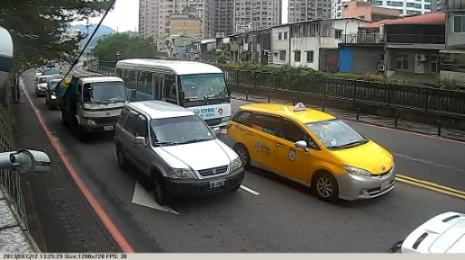

Before Tampering Detection Tampering Triggered (Lens Covered)

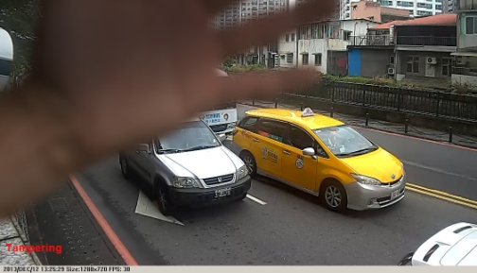

Before Tampering Detection Tampering Triggered (Glare)

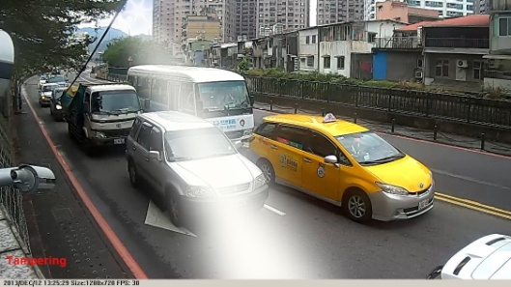

Before Tampering Detection Tampering Triggered (Camera Moved)

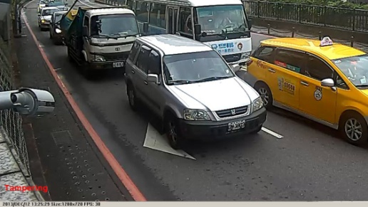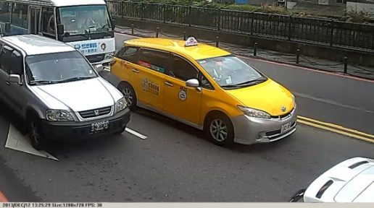

• Interval: The tampering detecting interval. Take the diagram below as example. The interval is set for 30 second; the camera lens is covered during 10 - 40 sec. At time point B, the camera compares the view with time point A, and sends an alarm when it founds that the lens is covered. At time point C, the camera compares the view with time point B, and sends an alarm when it founds that the lens is uncovered.

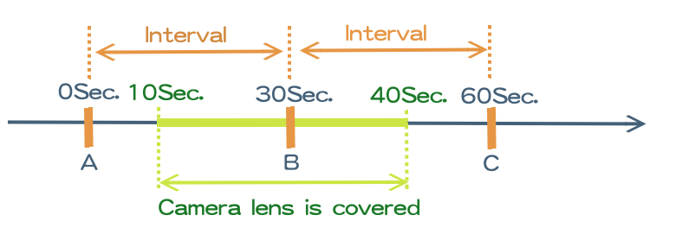

c. Record File



When an event occurs, the IP camera will record a video clip or take snapshot, and then send to mail/ FTP/ Samba. Select the file format to be saved.

• AVI File (with Record Time Setting): Save AVI video file. The video length is according to the value set in Record Time Setting.

• JPEG Files (with Record Time Setting): This option is enabled when selecting **JPEG** video format in **streaming 1** on **Video Setting**, this option can be enabled. Select this option to save several JPEG picture files. The successive picture files cover a period of time according to the value set in **Record Time Setting**.

• JPEG File (Single File with Interval Setting): Save a single JPEG picture file when the event occurs.

d. Record Time Setting



When an event occurs, the IP camera can record a video clip or take a snapshot, and then send it via mail/ FTP/ Samba. Select the video recording length before and after the event is detected.

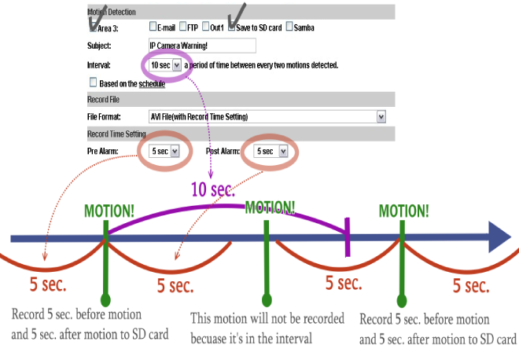

e. Network Dis-connected:

The IP Camera will scan the network. The image will be record to the SD card after the IP Camera detects network dis-connected, if set **Save to SD card**.

f. Network IP check:

After enabling IP Check, the IP camera can check if the network server is connecting. If the IP camera checking failed, the image will be recorded into the SD card.

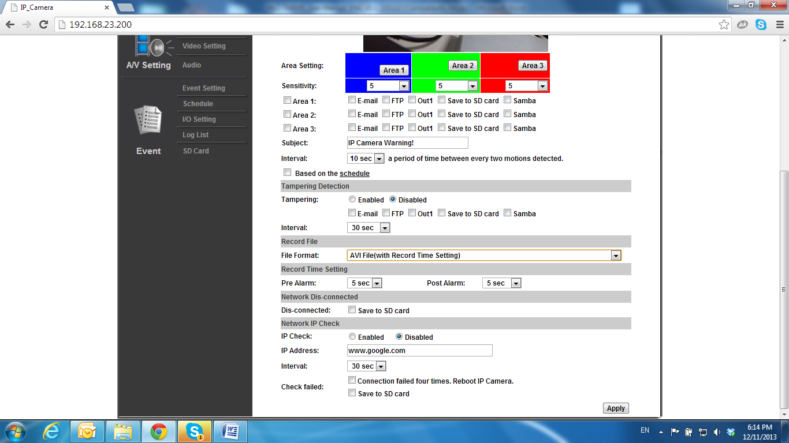

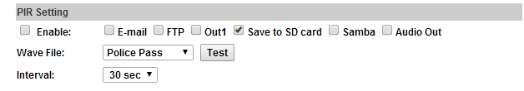g. PIR Setting

After enabling PIR select the action to be performed.

• Wave file: Select the Wave File to be triggered. You can test the audio before setting it.

• Interval: For example, when selecting "10 sec", once the event is triggered, it cannot be triggered again within 10 seconds.